**MODULE 2**

**ENVIRONMENTAL HYGIENE**

**Objectives**

1**.** Explain why there is need to maintain a clean environment

2.Get to know the best practices in environmental health and hygiene

**INTRODUCTION:**

Environmental hygiene addresses all the physical, chemical, and biological factors external to a person, and all the related factors impacting behaviours. Our living environment is composed of home, work and recreational centres where people spend their time. The provision of environmental health services extends to all these aspects of our lives. It encompasses the assessment and control of those environmental factors that can potentially affect health. The interaction between these environments and human activities results in various types of hazards that may adversely affect human health. To cause a disease, they must be introduced into our bodies**.** High standards of environmental hygiene, through proper cleaning, disinfecting and waste management regimes, are important in minimising the risk of transmission of infection.

Infection is a major risk related to improper equipment reprocessing, despite modern technologies and procedures. Achieving effective disinfection and sterilization is essential for ensuring that medical and surgical equipment/devices do not transmit infectious pathogens to clients/patients/residents or staff.

Effective reprocessing of medical equipment/devices is a process comprised of many components

This module is intended for health care providers to ensure that the critical elements and methods of cleaning, disinfection and sterilization are incorporated into health care procedures. The module describes essential elements and methods in the safe handling of contaminated medical supplies/equipment/devices. This should be practiced in all settings where care is provided, across the continuum of health care. This includes settings where emergency (including pre-hospital) care is provided, hospitals, complex continuing care facilities, rehabilitation facilities, long-term care homes, outpatient clinics, community health centres and clinics, independent health facilities, out of hospital premises, physician offices, dental offices, offices of other health professionals, public health and home health care, Emphasizes:

1. Appropriate cleaning and/or disinfection of health care equipment, supplies and surfaces or items
2. Individual staff responsibility for keeping clients/patients/residents, themselves and co-workers safe

* A clean environment contributes to prevention of infections.
* Most areas require at least daily cleaning.
* Frequently touched surfaces are a high risk for cross-transmission because they hold the pathogens that are transferred from people’s hands. These areas should be given extra attention to these frequently touched surfaces during their routine cleaning.



**Definitions**

Difference between cleaning, disinfection, and sterilization:

**Cleaning removes germs,** dirt, and impurities from surfaces or objects. Cleaning works by using soap (or detergent) and water to physically remove germs from surfaces. This process does not necessarily kill germs, but by removing them, it lowers their numbers and the risk of spreading infection.

**Disinfection** is the process of killing pathogens (kills germs)**.** Spores are not destroyed.Disinfecting works by using chemicals to kill germs on surfaces or objects. Spores are bacteria protected by a hard shell. One of the methods applied to kill Spores is use of very high temperatures.

**A disinfectant** is a liquid chemical that can kill many or all pathogens except spores. The use of disinfectants is critical to preventing transmission of infectious pathogens from contaminated surfaces and medical equipment to patients/residents etc.

**Sterilization-**This refers to the complete removal of all organic matter, including spores and viruses.

**Infection Control Measures**

* Provide all persons with their own personal care equipment to prevent pathogen transmission.
* Do not take equipment from 1 person’s room to use for another person. Even if un-used, do not take the item from 1 room to another.
* Keep tables, counters, Wheel chair trays and other surfaces clean and dry.
* Label bottles with a person’s name and the date the bottle was opened.
* Keep bottles and fluid containers tightly capped or covered.
* Use leak proof plastic bags for soiled linens (beddings, towels, gowns etc) and other items.
* Do not shake lines or equipment. Use a dump cloth for dusting.
* Clean from clean to dirty areas. This prevents soiling a clean area.
* Clean away from your body. Do not dust, brush or wipe toward yourself. Otherwise you transmit microbes to your skin, hair and clothing.
* Hold equipment and linens away from your uniform
* Pour urine and faeces directly into toilets. Avoid splashes
* Do not sit on the person’s bed or chair. You will pick up microbes. You will transfer them to the next surface that you sit on.
* Do not use items on the floor. The floor is contaminated.
* Cleaning must be carried out immediately following use of the equipment
* All instruments must be disassembled as much as possible before cleaning
* Items must be cleaned using appropriate cloths and brushes, which must not be used for other purposes. They must be cleaned after use and replaced regularly.
* A dirty-to-clean workflow should be maintained throughout. Two sinks are needed: one for cleaning and one for rinsing with separate areas for setting down dirty and clean instruments.
* Items must be washed thoroughly. Water should be changed during washing if it becomes heavily soiled.
* The sink used for manual cleaning should not be used for other purposes (a separate hand wash basin is required in the immediate area)
* Fill the sink with a fresh detergent solution for each set of instruments

[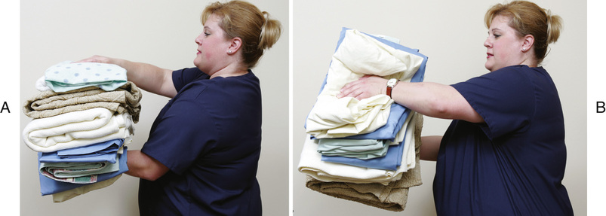](https://www.google.com/url?sa=i&url=https%3A%2F%2Fnursekey.com%2Fbedmaking%2F&psig=AOvVaw0sgtjv5Oh7bIEp5VTqzqVG&ust=1588158418192000&source=images&cd=vfe&ved=0CAIQjRxqFwoTCJj19Kn9iukCFQAAAAAdAAAAABAD)

Fig: healthcare provider Holding linens away from your uniform

1. **Cleaning of equipment**

Cleaning removes approximately 80–90% of microbial contamination.

Contaminated equipment is cleaned and decontaminated with approved disinfectant. This should be done

* Upon completion of task
* At once for obvious contamination
* At the end of your work shift when surfaces became contaminated since the last cleaning.

**Warning:** Use a brush and a dustpan or tongs to clean up broken glass. Never pick up broken glass with your hands, not even with gloves. Discard broken glass into a puncture resistance container.

**How to clean**

* Practice hand hygiene
* Wear personal protective equipment PPE to clean items contaminated with blood, body fluids, secretions and excretions.
* Fully immerse the item in order to avoid splashing. Do not clean items under running water.
* Work from clean to dirty areas.
* Rinse the items in cold water to remove organic matter. Heat makes organic matter thick, sticky, and hard to remove.
* Wash the item with soap and hot water
* Scrub thoroughly. Use a brush if necessary
* Rinse the item in warm water. The water should be 35ºC (lukewarm to touch), or cooler. Dry the item
* Disinfect the item. Or send it to the supply department to be sterilized
* Disinfect equipment used and the sink
* Discard PPE
* Practice hand hygiene

[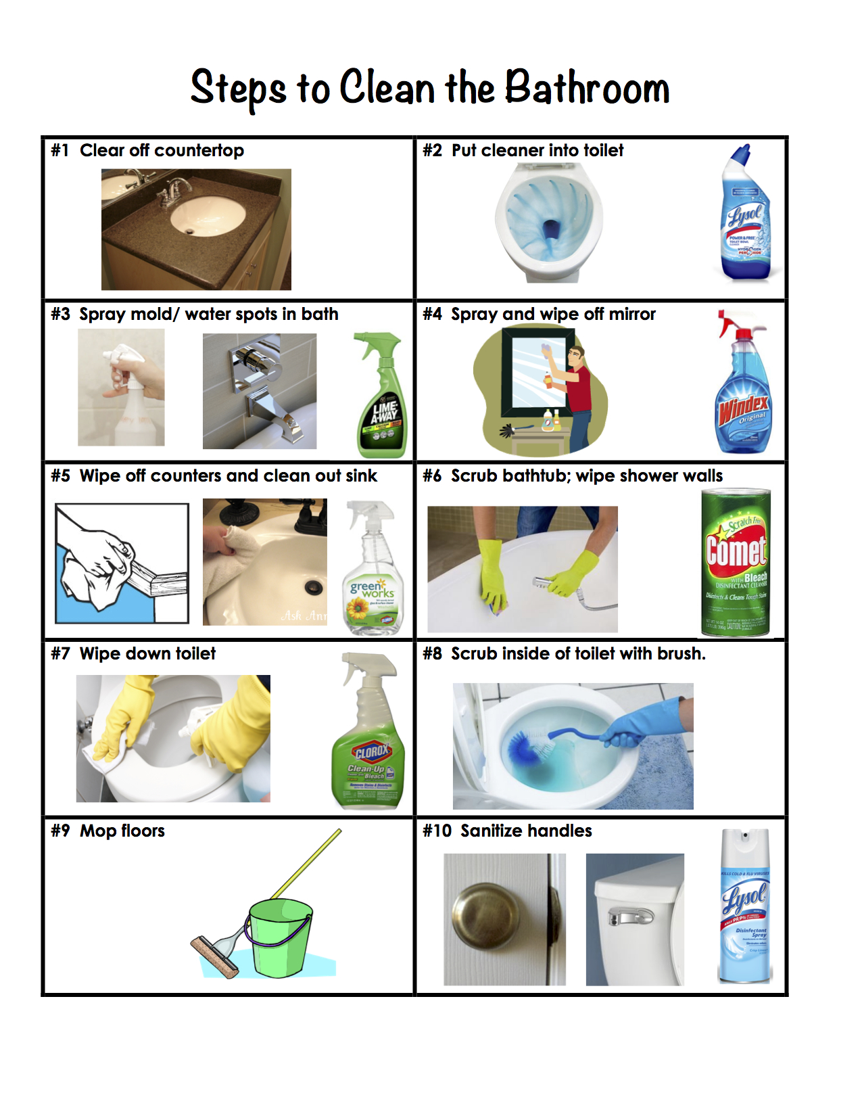](https://www.google.com/url?sa=i&url=https%3A%2F%2Foccupationhomemaking.wordpress.com%2F2015%2F05%2F01%2Fsteps-to-clean-a-bathroom%2F&psig=AOvVaw1crWP4sZFNRmbL0EIY9rOF&ust=1588232075019000&source=images&cd=vfe&ved=0CAIQjRxqFwoTCJiXxtyPjekCFQAAAAAdAAAAABAD)

[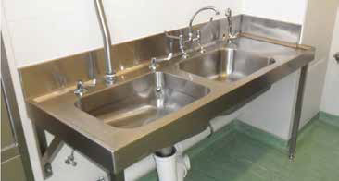](https://www.google.com/url?sa=i&url=https%3A%2F%2Fwww.afindcom.com%2Fhospital-sluice-sinks%2F&psig=AOvVaw3fvBn3uVE2PFqpSr_nRqEM&ust=1588158657585000&source=images&cd=vfe&ved=0CAIQjRxqFwoTCPDr4Jj-iukCFQAAAAAdAAAAABAD)

Wash-up sluice sink

[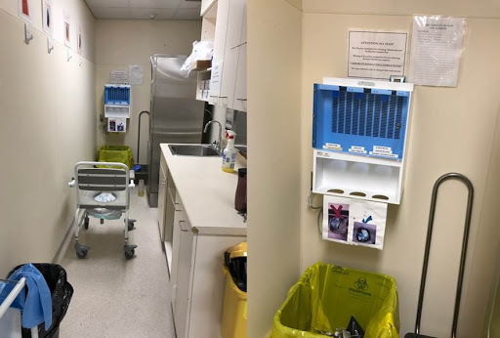](https://www.google.com/url?sa=i&url=http%3A%2F%2Fedeblog.com%2Fauthor%2Fsteve-socransky%2Ffeed%2F&psig=AOvVaw16RX8ubBtlNuKyKry5f2K6&ust=1588159613082000&source=images&cd=vfe&ved=0CAIQjRxqFwoTCPCn1OCBi-kCFQAAAAAdAAAAABAL)

Fig: utility room

[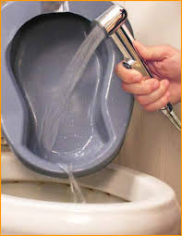](https://www.google.com/url?sa=i&url=http%3A%2F%2Fbedpanwash.com%2F&psig=AOvVaw2XvH15dyGtdWb2J5ceUv9e&ust=1588061352683000&source=images&cd=vfe&ved=0CAIQjRxqFwoTCJiu0duTiOkCFQAAAAAdAAAAABAD)

[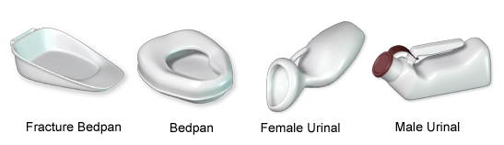](https://www.google.com/url?sa=i&url=https%3A%2F%2Fwww.rnpedia.com%2Fnursing-notes%2Ffundamentals-in-nursing-notes%2Fcleaning-bedpans-urinals%2F&psig=AOvVaw2NgvU3flpJ9Jra44et1HK2&ust=1588061176469000&source=images&cd=vfe&ved=0CAIQjRxqFwoTCIjtnomTiOkCFQAAAAAdAAAAABAo)

[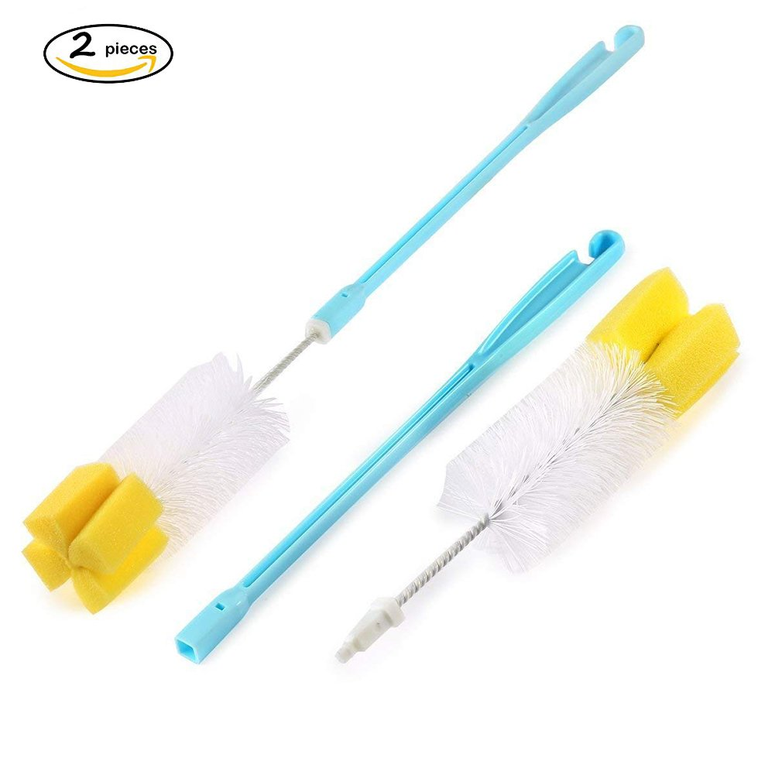](https://www.google.com/url?sa=i&url=https%3A%2F%2Fwww.amazon.com%2FPortable-Cleaning-Brushes-Handled-Plastic%2Fdp%2FB07D3SQF6Y&psig=AOvVaw0fIp7giwtqjZM2_FZKt2IS&ust=1588061443490000&source=images&cd=vfe&ved=0CAIQjRxqFwoTCPCo4YaUiOkCFQAAAAAdAAAAABAD)

Fig: Potable bedpan urinal brush

[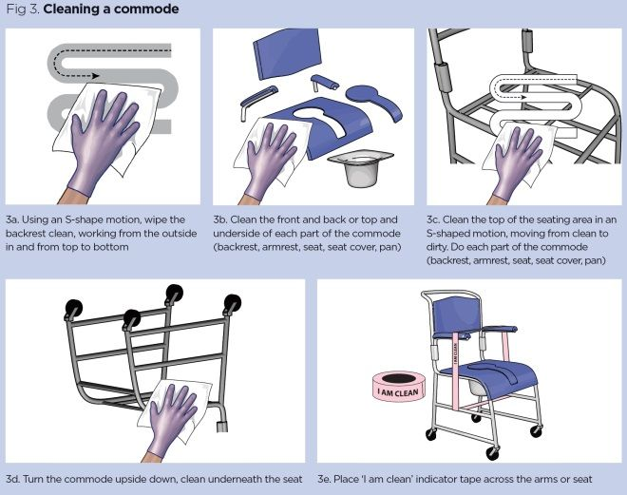](https://www.google.com/url?sa=i&url=https%3A%2F%2Fwww.nursingtimes.net%2Fclinical-archive%2Finfection-control%2Finfection-control-1-decontamination-of-non-invasive-shared-equipment-02-03-2019%2F&psig=AOvVaw19s-EIQ-OW4ezvzAj2Md1Y&ust=1588060060537000&source=images&cd=vfe&ved=0CAIQjRxqFwoTCLil8PKOiOkCFQAAAAAdAAAAABAS)

[](https://www.google.com/url?sa=i&url=https%3A%2F%2Ftemperature.co.uk%2Finfrared-thermometers-cleaning-storing%2F&psig=AOvVaw3QCUv6N_Ul2RnzdRcYcgz8&ust=1588062168050000&source=images&cd=vfe&ved=0CAIQjRxqFwoTCJDf4N-WiOkCFQAAAAAdAAAAABAX)

Fig: Cleaning an infrared thermometer

1. **DISINFECTION**

Disinfectants are used to clean objects and surfaces. They are used to clean counters, tubs, showers, and re-usable items. Such items include:

* Blood pressure cuffs
* Commodes and metal bedpans
* Wheelchairs and stretchers
* Furniture

**Follow below principles when disinfecting:**

* Disinfectants often call for the use of gloves or eye protection. For example, gloves should always be worn to protect your hands when working with bleach solutions.
* Do not mix cleaners and disinfectants unless the labels indicate it is safe to do so. Combining certain products (such as chlorine bleach and ammonia cleaners) can result in serious injury or death.
* Read the label directions carefully, as there may be a separate procedure for using the product as a cleaner or as a disinfectant. Disinfection usually requires the product to remain on the surface for a certain period.
* Pay close attention to hazard warnings and directions on product labels.

**How to disinfect**

* Daily, disinfect surfaces and objects that are touched often, such as desks, countertops, doorknobs, computer keyboards, faucet handles, and phones. Also disinfect specific areas, like bathrooms.
* Use disinfecting wipes on electronic items that are touched often, such as phones and computers. Pay close attention to the directions for using disinfecting wipes. It may be necessary to use more than one wipe to keep the surface wet for the stated length of contact time. Make sure that the electronics can withstand the use of liquids for cleaning and disinfecting.

[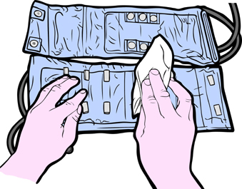](https://www.google.com/url?sa=i&url=http%3A%2F%2Finventorspot.com%2Farticles%2Fhospitals_30132&psig=AOvVaw37jRGPQABlB3wUW4FX6aaw&ust=1588061587497000&source=images&cd=vfe&ved=0CAIQjRxqFwoTCJjCocqUiOkCFQAAAAAdAAAAABAm)

Fig: Disinfection of a blood pressure cuff

[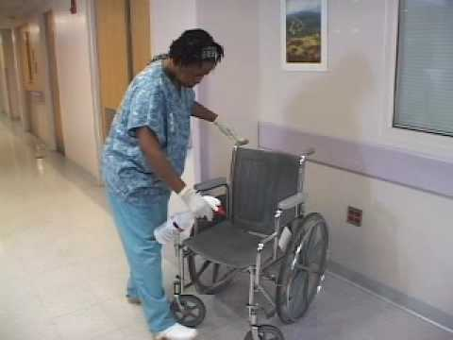](https://www.google.com/url?sa=i&url=https%3A%2F%2Fwww.tes.com%2Flessons%2FLTUWW1LFjdWKzA%2Finfection-control&psig=AOvVaw0zXygc8Cd_YqMH-K2iLaik&ust=1588061796166000&source=images&cd=vfe&ved=0CAIQjRxqFwoTCPi7va2ViOkCFQAAAAAdAAAAABAD)

Fig: Decontamination of a wheelchair

**Home care disinfection**

* Detergent and hot water are used to clean cooking, eating and drinking utensils and linens.
* Household disinfectants are used to clean cooking, eating and drinking utensils and linens
* Household disinfectants are used for surfaces -floors, toilets, tubs, and showers. Use the products the family prefers.

White vinegar and water are a good, disinfectant. You can use it to clean bedpans, urinals, commodes, toilets, mirrors, bathroom tiles, and so on.

To make a vinegar solution

-Mix 1 cup of white vinegar with 3 cups of water

-Label the container as “vinegar solution: 1 cup vinegar, 3 cups water

-Write the date, time, and your name on the label.

[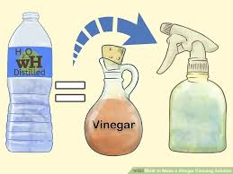](https://www.google.com/url?sa=i&url=https%3A%2F%2Fwww.wikihow.com%2FMake-a-Vinegar-Cleaning-Solution&psig=AOvVaw2gFBj2MDVGLVCZuIWyWeCV&ust=1588158851750000&source=images&cd=vfe&ved=0CAIQjRxqFwoTCMDUx_j-iukCFQAAAAAdAAAAABAD)

Fig: Homemade vinegar cleaning solution

**3. Sterilization**

Re-usable medical devices requiring sterilization should only be reprocessed via a Central Sterile Services department (SSD), as these have the equipment and expertise to ensure that sterile items are always produced.

**Methods of Sterilization**

* Steam is the preferred method for sterilizing critical medical and surgical instruments that are not damaged by heat, steam, pressure, or moisture.
* Cool steam- or heat-sterilized items before they are handled or used in the operative setting.
* Use low-temperature sterilization technologies for reprocessing critical patient-care equipment that is heat sensitive.

Comply with the sterilizer manufacturer’s instructions e.g., time, temperature, concentration.

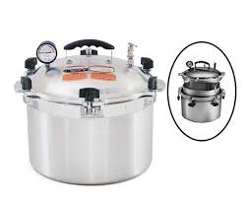

Fig: Portable autoclave for steam sterilization

**Homecare sterilization**

You can use boiling water to sterilize items in the home

* Use a pot big enough to hold the items.
* Wash the items with soap and hot water.
* Fill the pot with cold water. Completely cover all items with water.
* Bring the water to a full boil
* Boil the items for 10 minutes. Add 1 minute for each 1000 of feet of elevation. For example, if a home is 2000 feet above sea level, boil items for 2 minutes for a total of 12 minutes.
* Turn off the heat
* Use tongs to remove the hot items to a clean towel. Remove items 1 at a time
* Let the items air- dry
* Put the items away as the family prefers

**Note**: Many people use dishwashers for baby bottles. However, many dishwashers do not get hot enough to sterilize item

**4. Waste management**

Waste management is the handling and safe disposal of infectious and non-infectious waste. The aims of waste management are to ensure safe and environmentally friendly destruction or reprocessing of healthcare waste.

Examples of biohazard waste:

* Anything that is soaked in blood (gloves, gauze, gowns etc.) and any waste produced in patient’s rooms
* Contaminated sharps

Special measures are used to discard regulated waste.

**Use of Biohazard bags**

This medical/biohazardous cannot be disposed of with your normal garbage due to many factors. This waste must be disposed in a separate specified container/bags. Unlike your normal trash bags, these biohazard bags must be equipped to handle potentially dangerous material. Specifically, there are many types of bags depending on the conditions: Medical/Biohazardous waste pickup containers, laboratory biohazardous waste containers, solid medical/biohazardous waste disposal, pharmaceuticals drug disposal bags etc

Follow standard procedures for handling waste, which may include wearing gloves. Place no-touch waste baskets (e. g foot operated bins) where they are easy to use. Throw disposable items used to clean surfaces and items in the trash immediately after use. Avoid touching used tissues and other waste when emptying waste baskets. Wash your hands with soap and water after emptying waste baskets and touching used tissues and similar waste.

[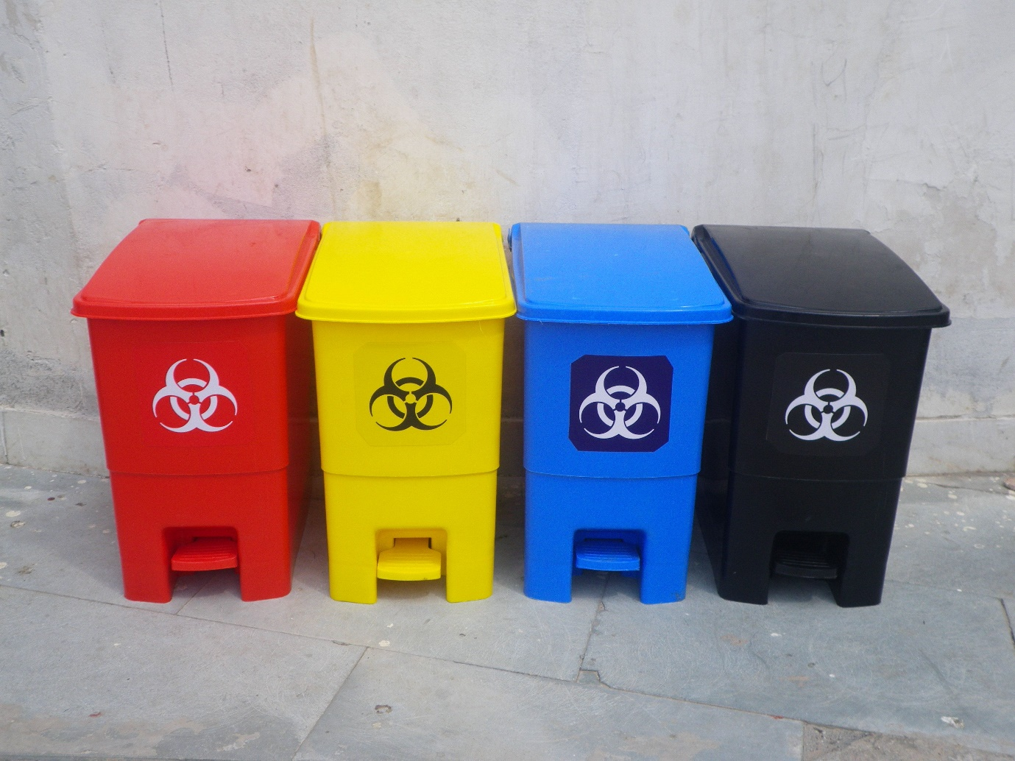](https://www.google.com/url?sa=i&url=http%3A%2F%2Fwww.biomedicalwastebins.com%2Fbio-medical-waste-disposal-bin-32l-4714816.html&psig=AOvVaw3h_WVMd9nva7W3M4dnAK8j&ust=1588159207784000&source=images&cd=vfe&ved=0CAIQjRxqFwoTCKC_nJ6Ai-kCFQAAAAAdAAAAABAD)

Fig: Bio Medical waste Disposal Bin

**Home care: waste**

Dressings, gloves, and other care items are used in home care. So are syringes, needles and sharps (such as razors). The patient or family may syringe or needles, safety razors for shaving and lancets for blood glucose testing.

[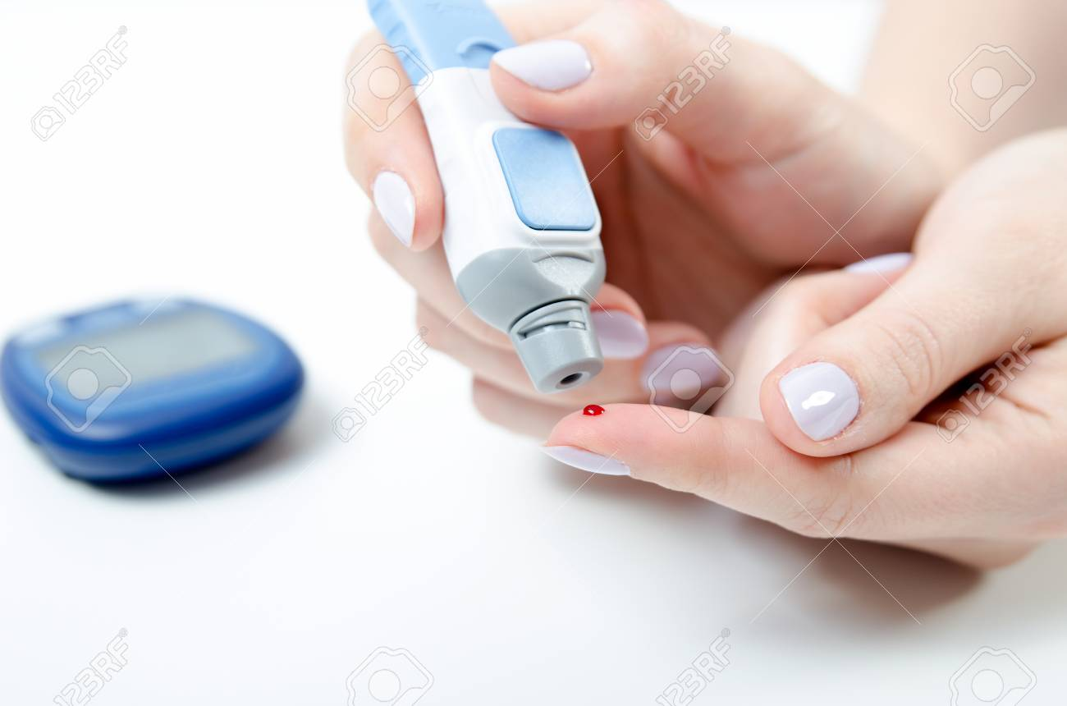](https://www.google.com/url?sa=i&url=https%3A%2F%2Fwww.123rf.com%2Fphoto_94816575_diabetes-doing-blood-glucose-measurement-woman-using-lancet-and-glucometer-.html&psig=AOvVaw1Y-LWJV4Ne-4H4WR0RPjy6&ust=1588159834509000&source=images&cd=vfe&ved=0CAIQjRxqFwoTCKj1-MuCi-kCFQAAAAAdAAAAABAV)

Fig: Monitoring of blood glucose

[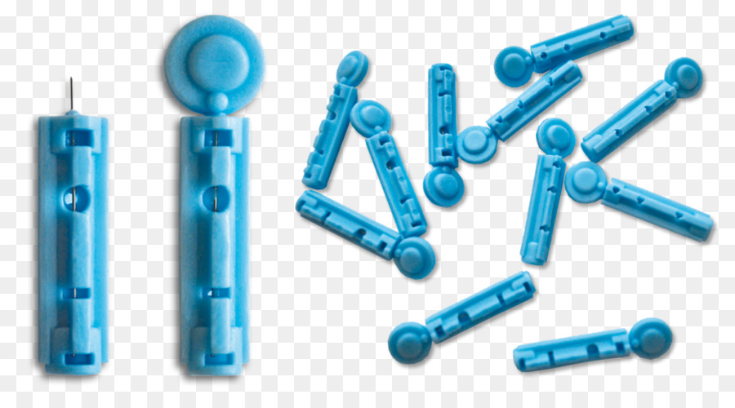](https://www.google.com/url?sa=i&url=https%3A%2F%2Fwww.cleanpng.com%2Fpng-blood-lancet-onetouch-ultra-blood-glucose-meters-b-3973101%2F&psig=AOvVaw1Y-LWJV4Ne-4H4WR0RPjy6&ust=1588159834509000&source=images&cd=vfe&ved=0CAIQjRxqFwoTCKj1-MuCi-kCFQAAAAAdAAAAABAa)

Fig: Lancets

[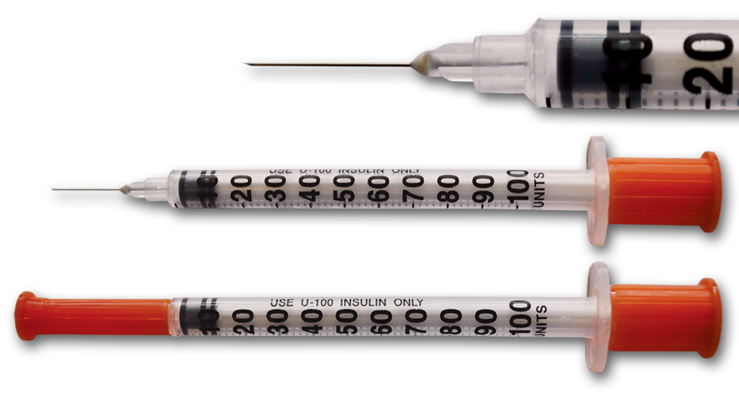](https://www.google.com/url?sa=i&url=https%3A%2F%2Fmathisfornursestoo.wordpress.com%2F2013%2F04%2F19%2Fa-syringe-full-of-insulin-helps-the-blood-sugar-go-down%2F&psig=AOvVaw3OIjSHsfLuw1nOQ5v6Li93&ust=1588159999941000&source=images&cd=vfe&ved=0CAIQjRxqFwoTCPjz4ZqDi-kCFQAAAAAdAAAAABAD)

Fig: Insulin syringe

**Proper disposal:**

* Protects neighbors, children, pets, housekeepers, sanitation workers etc. from injury and infection. HIV, AIDS, and hepatitis B and C are risks.
* Prevent needle sharing and re-using sharps.
* Protects the environment
* Do not throw loose needles, syringes or sharps into the trash or into a recycling bin
* Do not flush needles, syringes, or sharps down the toilet.
* Do not put needles, syringes or sharps in recycling containers for bottles, plastics, and paper

Proper disposable of used needles, syringes and sharps:

1. Put them in a commercial or household sharps container right after use. A household container can be a hard plastic, puncture resistant container with a screw-on lids are examples. Secure the lid in place with heavy tape for added protection.
2. Label the container with “DO NOT RECYCLE” or “SHARPS “label.
3. Put sharps in the container sharp-first
4. Do not use soda cans or bottles, milk cartons, glass bottles, coffee cans, aluminum cans, or other containers that are not puncture resistant
5. Keep storage containers where children cannot reach them

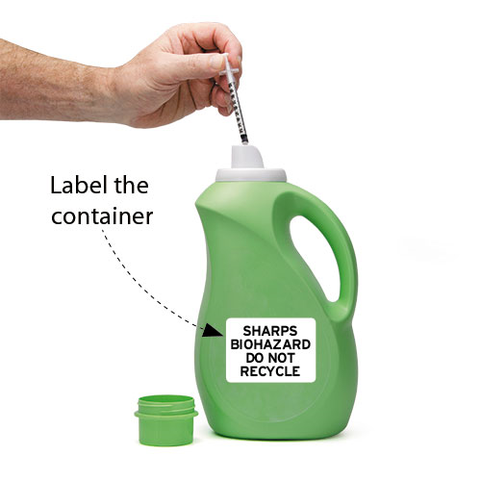

Fig: Homemade sharps container

1. Disposal options:

* Drop- off collection sites-filled sharps containers are taken to a collection site. Hospital, doctors’ offices, clinics, pharmacies, health department are examples. So are medical waste facilities.
* Household hazardous waste are collection sites. Sharps containers are placed in sharps collection bins at a collection site.
* Residential special waste pick -up services. Used sharps are placed in a special recycling-type container. The container is placed outside the home for collection by special waste handlers. Programs have a regular pick up times or require a call for pick- up.
* Mail back programs. Used sharps are placed in special containers and mailed to a collection site.
* Home needle destruction services. Such devices melt or burn the needle. The syringe and destroyed needle are placed in the trash.

Proper disposal of Dressings, gloves, soiled bed protectors, and other care items:

* Place them in plastic bags
* Close the bags securely
* Label each bag with “Do Not Recycle” label.
* Place the bags in a trash can with a lid
* Make sure animals cannot get into the trash can.

[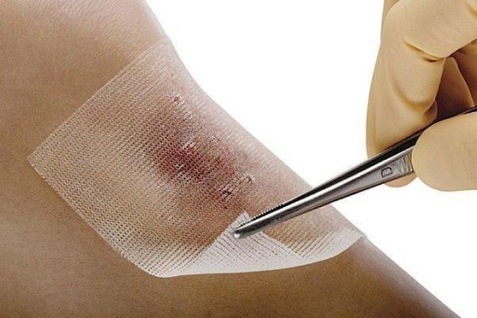](https://www.google.com/url?sa=i&url=https%3A%2F%2Fifpnews.com%2Fnewly-developed-dressing-accelerates-wound-treatment&psig=AOvVaw3c-i5jNxfkOFykpbAo9ok7&ust=1588159449904000&source=images&cd=vfe&ved=0CAIQjRxqFwoTCICphKKBi-kCFQAAAAAdAAAAABAJ)

**Fig: Used gauze**

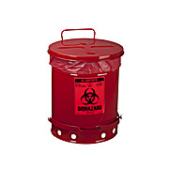

Fig: Waste disposal containers

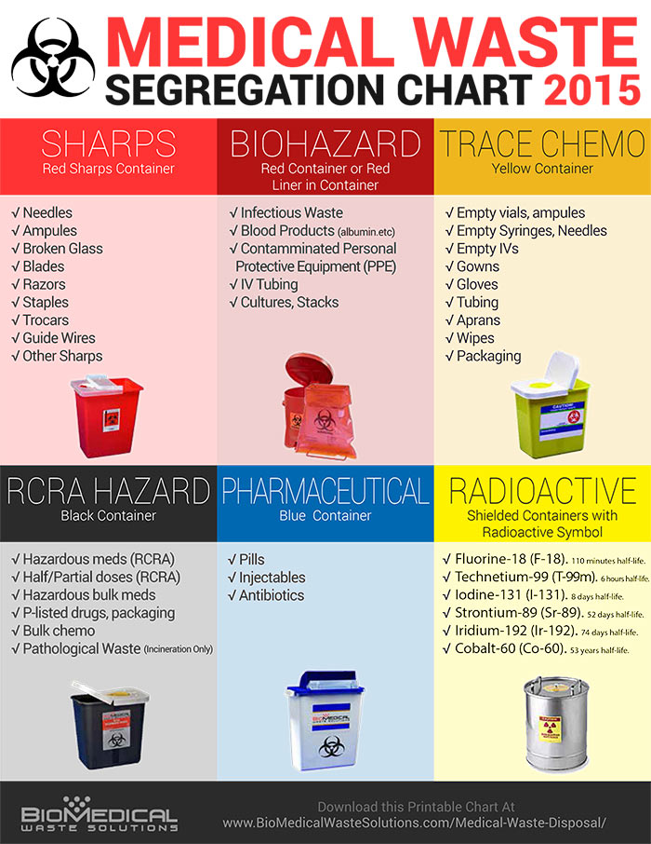

5. **Laundry- Linen handling & storage**

All linen is handled, stored, transported, and processed in a manner that will prevent contamination and maintain a clean environment for patients, health care providers, and visitors.  
**Procedure:**1. Soiled or ‘dirty’ linen is:  
a. Bagged at site of collection and is transported to a specific area in a ‘soiled linen’ bag provided by the laundry service. Minimal handling of soiled linen is advised.  
b. Soiled linen is placed in a covered linen storage receptacle. Linen that is grossly contaminated with blood or other bodily fluids should be handled by staff wearing Personal Protective Equipment (PPE) and is put into a red plastic bag labelled “Biohazard”. Due to the relative infrequency of this occurrence, linens in this condition are discarded as biohazardous waste.   
c. Soiled linen bags are not over-filled, preventing complete closure.  
d. Linen bags are washable and are laundered by the service provider.  
e. Soiled linen bags are handled as if hazards were present.  
f. Clothing, furniture, and clean linen do not come in contact of the soiled linen bag.  
2. Clean linen is:  
a. Stored in an area separate from the storage of any dirty linens.  
b. If the linen storage area includes other patient care equipment or supplies, the linen is stored on shelving that has been cleaned with an environment disinfectant and covered with a drape to prevent contamination.  
c. Clean linen (including pillows) is not stored on the floor, chair, or counter top.  
Linen used for patient use is free of tears, fraying, and damage. It is the responsibility of the laundry service to inspect and replace worn linen. Worn, clean linen identified by responsible personnel will be immediately placed in the soiled linen bag for pick-up by the linen service provider.

[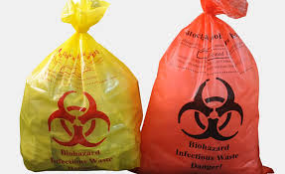](https://www.google.com/url?sa=i&url=https%3A%2F%2Fipcassociates.com%2Fcolor-coded-bags%2F&psig=AOvVaw3vADxETz4I7gGjd7v_BaOV&ust=1588156073975000&source=images&cd=vfe&ved=0CAIQjRxqFwoTCJic38f0iukCFQAAAAAdAAAAABAD)

Fig: Color coded bags